University of Pittsburgh at Johnstown

Electrical and Computer Engineering Department SENIOR DESIGN COE1199

Cycle Statistic Tool

Weekly Memorandum
To: | Maddumage Karunaratne
From: | Jacob Hoffman  Cody Klingler

cc:
Date: | 03/29/2021

Re:

Achievements:

Cody: I encountered another strain gauge issue that took almost a whole week to fix. The ADC/amplifier was outputting only the maximum value that it can, which indicated to me that the voltage between the outputs of the wheatstone bridge was too high. To fix this I tried implementing new strain gauges in a full bridge and also reconstructing the permanent circuit multiple times. The problem turned out to be that the gain setting on the ADC was too low. This was fixed by setting gain to its maximum value. During my attempts to fix this issue I constructed two more circuits to be mounted on the crank arm of the bicycle, and implemented a more redundant and accurate design for the strain gauges.

Jacob: A test application was configured and set up to run and search for bluetooth devices. Most of the code used here was provided by the developer of the Plugin.BLE package. I configured the sample application to only search for Bluetooth Low Energy. Then, the sample application was merged into the existing design. Currently, devices can be searched for, but they can’t be connected to. Cody and I also made a GATT Attribute table to describe the bluetooth services that will transmit our data.

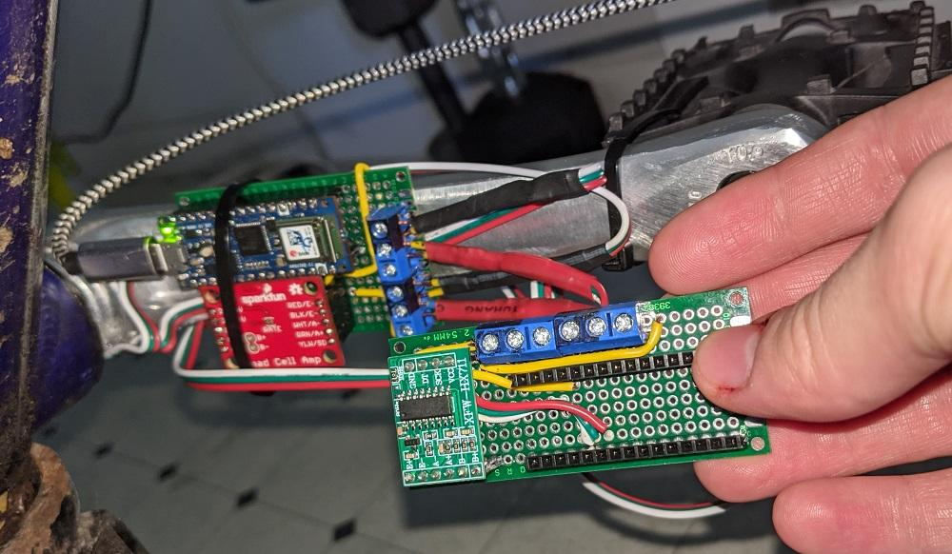
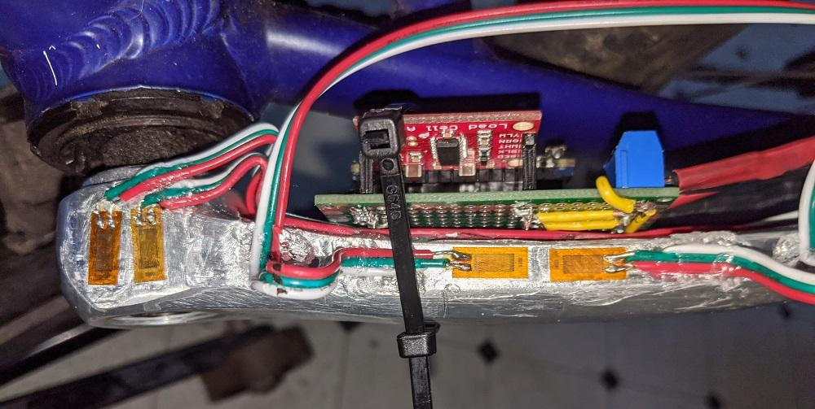
Figures 1 and 2: Full Bridge, Permanent Circuits

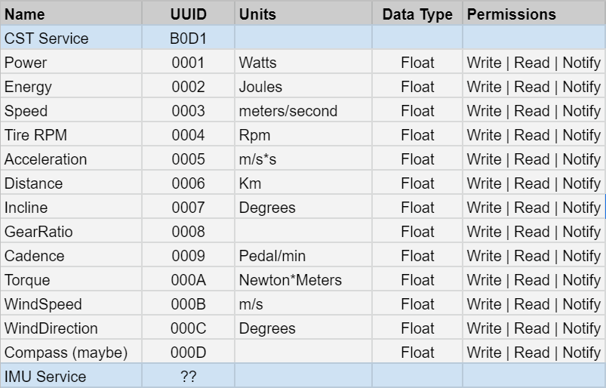
Figure 3: GATT Attribute Table

Issues Encountered and Solved:

Cody: The ADC/Amplifier was outputting its maximum value. This was fixed by changing the gain to the maximum setting.

Jacob: Once the sample application was configured and began working, it was searching for classic and low-energy bluetooth devices, which was causing a large amount of devices to be discovered (not necessarily a huge issue). This was resolved by programming the bluetooth plugin to only return devices that are using low-energy.

Issues Encountered and Unresolved:

Cody: None.

Jacob: The application was running and I was able to search for bluetooth devices nearby. After working on the project a little more, I am currently getting an unexplainable runtime error whenever trying to build the project.

Goals and Tasks For Next Week:

Cody: The new classes in the microcontroller will be implemented this week and a circuit for the primary microcontroller will be made so that it may be placed in its housing. Assuming everything goes well, the bike should be rideable this week.

Jacob: The BLE connectivity is still being finished. Reading characteristics from the CST across bluetooth needs to be implemented.

Project Schedule:

Cody: The hardware path is behind. The wind sensing unit still has not been designed, bluetooth has yet to be tested, and not all of the hardware is mounted so it hasn’t been weatherproofed.

Jacob: Coding the mobile application is scheduled until 04/03/2021. The scheduling for testing bluetooth was delayed on the GANTT chart and is scheduled until 04/02/2021.

Project Logbook:

Cody:
3/23/2021 - 4.0 hours
I was experiencing strain gauge trouble once again. This time only maximum values were being output by the ADC. I converted the strain gauge design to be a full bridge because I thought that maybe soldering resistors from the bridge was altering their resistance, which could cause these bad measurements . The full bridge is more accurate, and is also helpful in a scenario where a gauge fails again because the design can be converted to a half bridge without any hassle.

3/24/2021 - 8.25 hours
I soldered the new full bridge gauges and resoldered our circuit. I tried multiple designs and have been testing for resistance in wires. Nothing so far has fixed the problem

3/27/2021 - 9.75 hours
Fixed the strain gauge issues. I think that the gain for HX711 is automatically set based on the input which would explain why I was experiencing the issues sometimes and not others. I had tried changing the gain manually before, but since the value was always at it's maximum, I was turning the gain down. The problem was actually solved by setting the gain to its maximum value. I constructed 2 more permanent circuits, one with the expensive HX711 and another with the cheap HX711.

3/28/2021 - 5.25 hours
This period of time was spent finalizing code for the microcontrollers. I changed the classes that were created last week to make it easier to retrieve and update bluetooth values. I expect this to take 2 to 3 more days of work.

Jacob:

03/21/21 - 3 hours

Completed some permissions and UI troubleshooting for the bluetooth on the application. There are still major issues with using the current plugin. A revised implementation using Plugin BLE was set up and used for this troubleshooting. The project team is going to try implementing BLE connectivity in the Android native application. We believe this might provide a solution to our project.

03/25/21 - 5 hours

After some research into developing a native Android application, I think it will end up being too much work for the amount of time we have left. I’m continuing to have issues with the xamarin forms project not being responsive once it starts scanning through the Plugin.BLE nuget package. I spent some time troubleshooting this issue, but have not found a solution.

03/26/21 - 4 hours

I found a demo application that was provided by the Plugin.BLE nuget package developer. It was outdated and took a while to configure, but I got it to run. It can scan for nearby bluetooth devices, including BLE. I set up the application to only scan for BLE devices since that is what we will be searching for. I am beginning to think if it would be easier to simply do a custom connection attempt with the CST device instead of a random search for all nearby devices, but without Cody here with the device, this idea is kind of hard to do.

03/27/21 - 4 hours

I began merging the demo application that came with the nuget package with the companion application’s existing code. This is taking a bit of time because I am having to individually re-make all the pages and view models for the main application. This is still a work in progress.

03/28/21 - 6 hours

I finished up merging most of the BLE application. It was working, but I am having errors when compiling now. My plan is to finalize merging the two apps and then wrap the bluetooth functionality with a tabbed page view which basically extends the rest of the app. I need to get the app running again so that I can confirm the ability to search for devices and then set up a way to begin reading data from the CST’s characteristics.
Task Division:
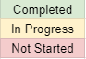
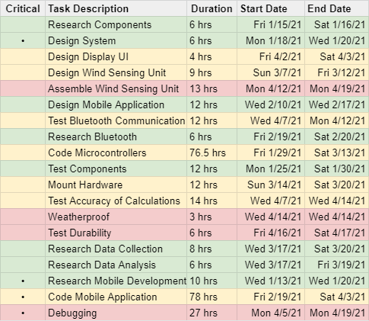
GANTT Chart:

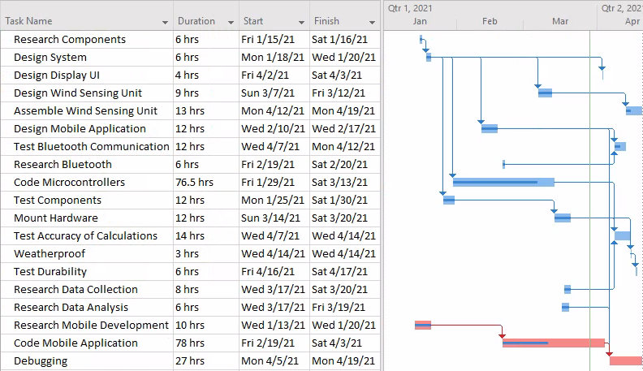

Bill of Materials:

